AIM:- To execute code of food expiry and waste reduction system in c programming.
Program:-
#include <stdio.h>
#include <stdlib.h>
#include <string.h>
#define MAX 50
typedef struct {
int id;
char name[30];
char category[20];
int quantity;
int expiryDay;
int expiryMonth;
int expiryYear;
}
Food;
Food items[MAX];
int count = 0;
void addFood();
void viewAll();
void checkExpiry();
void menu();
int main()
{
int choice;
printf("\n=== FOOD EXPIRY SYSTEM ===\n");
while(1) {
menu();
printf("Choice: ");
scanf("%d", &choice);

switch(choice) {
case 1: addFood(); break;
case 2: viewAll(); break;
case 3: checkExpiry(); break;
case 4:
printf("\nThank You!\n");
exit(0);
default:
printf("\nInvalid!\n");
}
}
return 0;
}
void menu() {
printf("\n--- MENU ---\n");
printf("1. Add Food\n");
printf("2. View All\n");
printf("3. Check Expiry\n");
printf("4. Exit\n");
}
void addFood() {
if(count >= MAX) {
printf("\nInventory Full!\n");
return;
}
items[count].id = count + 1;

printf("\nFood Name: ");
scanf("%s", items[count].name);

printf("Category: ");
scanf("%s", items[count].category);

printf("Quantity: ");
scanf("%d", &items[count].quantity);

printf("Expiry Date (DD MM YYYY): ");
scanf("%d %d %d", &items[count].expiryDay,
&items[count].expiryMonth, &items[count].expiryYear);

count++;
printf("\nAdded Successfully!\n");
}

void viewAll() {
if(count == 0) {
printf("\nNo Items!\n");
return;
}

printf("\n--- ALL ITEMS ---\n");
printf("ID\tName\t\tCategory\tQty\tExpiry\n");
printf("--------------------------------------------------\n");

for(int i = 0; i < count; i++) {
printf("%d\t%-15s\t%-10s\t%d\t%02d-%02d-%d\n",
items[i].id, items[i].name, items[i].category,
items[i].quantity, items[i].expiryDay,
items[i].expiryMonth, items[i].expiryYear);
}
}
void checkExpiry() {
int today, month, year;
printf("\nEnter Today's Date (DD MM YYYY): ");
scanf("%d %d %d", &today, &month, &year);

printf("\n--- EXPIRY ALERTS ---\n");
int found = 0;

for(int i = 0; i < count; i++) {
int expYear = items[i].expiryYear;
int expMonth = items[i].expiryMonth;
int expDay = items[i].expiryDay;
if(expYear < year ||
(expYear == year && expMonth < month) ||
(expYear == year && expMonth == month && expDay < today)) {
printf("EXPIRED: %s (Qty: %d)\n", items[i].name, items[i].quantity);
found = 1;
}
else if(expYear == year && expMonth == month && expDay - today <= 3) {
printf("CRITICAL: %s expires in %d days\n", items[i].name, expDay - today);
found = 1;
}
else if(expYear == year && expMonth == month && expDay - today <= 7) {
printf("WARNING: %s expires in %d days\n", items[i].name, expDay - today);
found = 1;
}
}

if(!found) {
printf("All items are fresh!\n");
}
}

Output:-

Step-1:
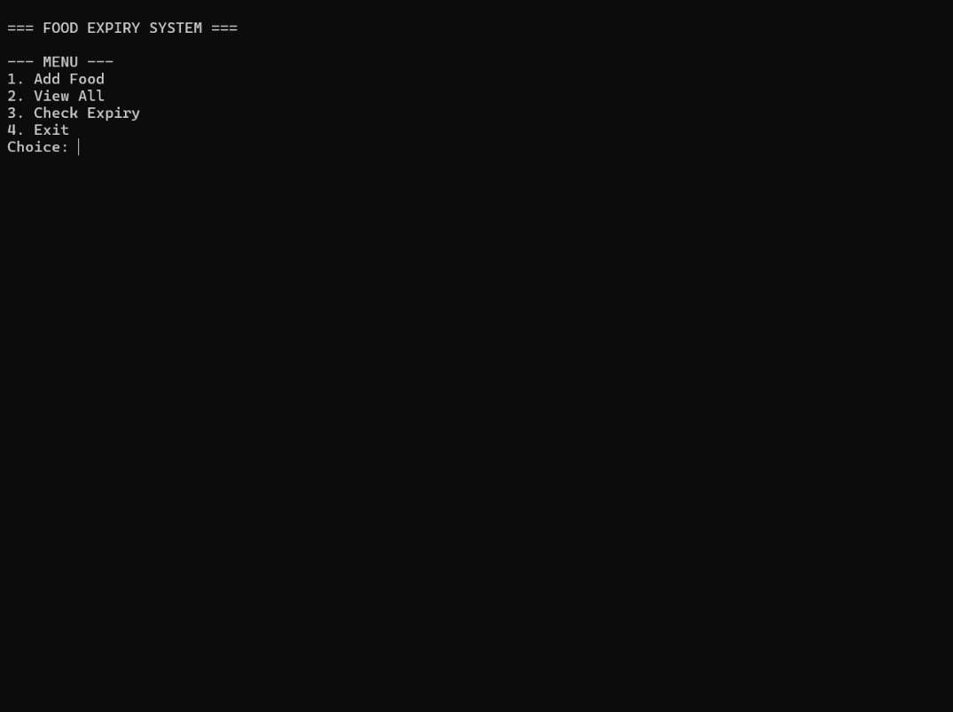

Step- 2:
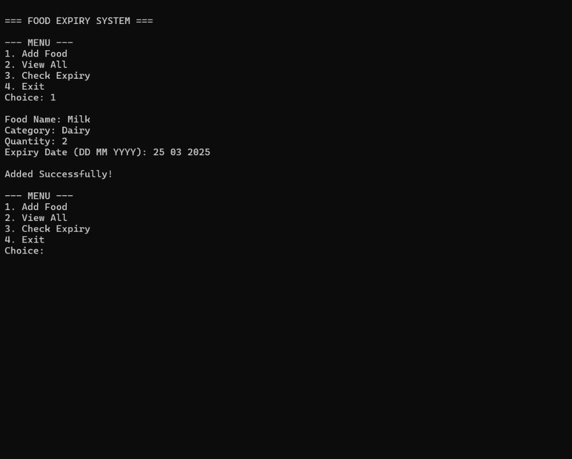
Step- 3:-
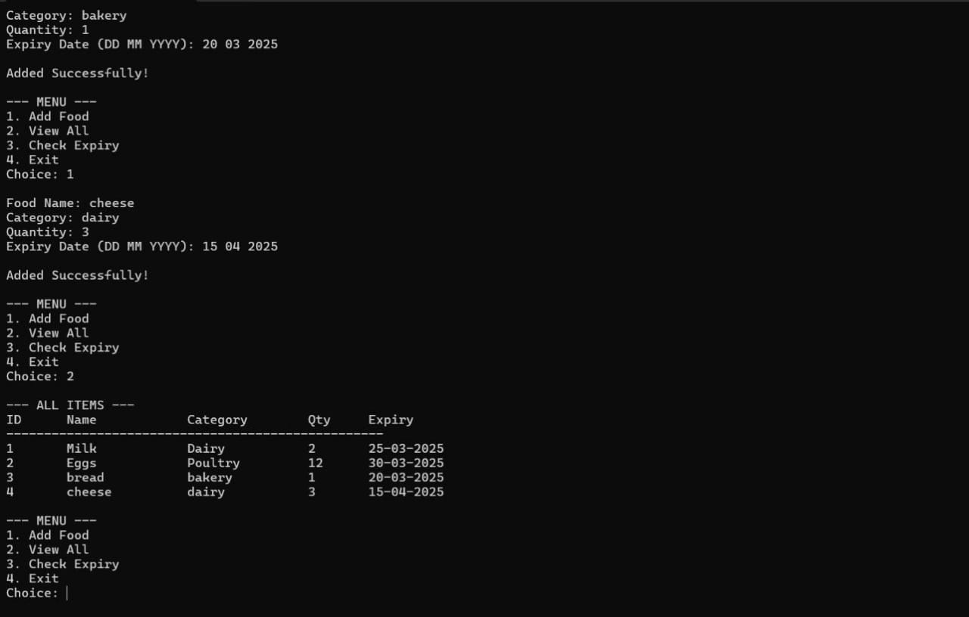

Step- 4:-
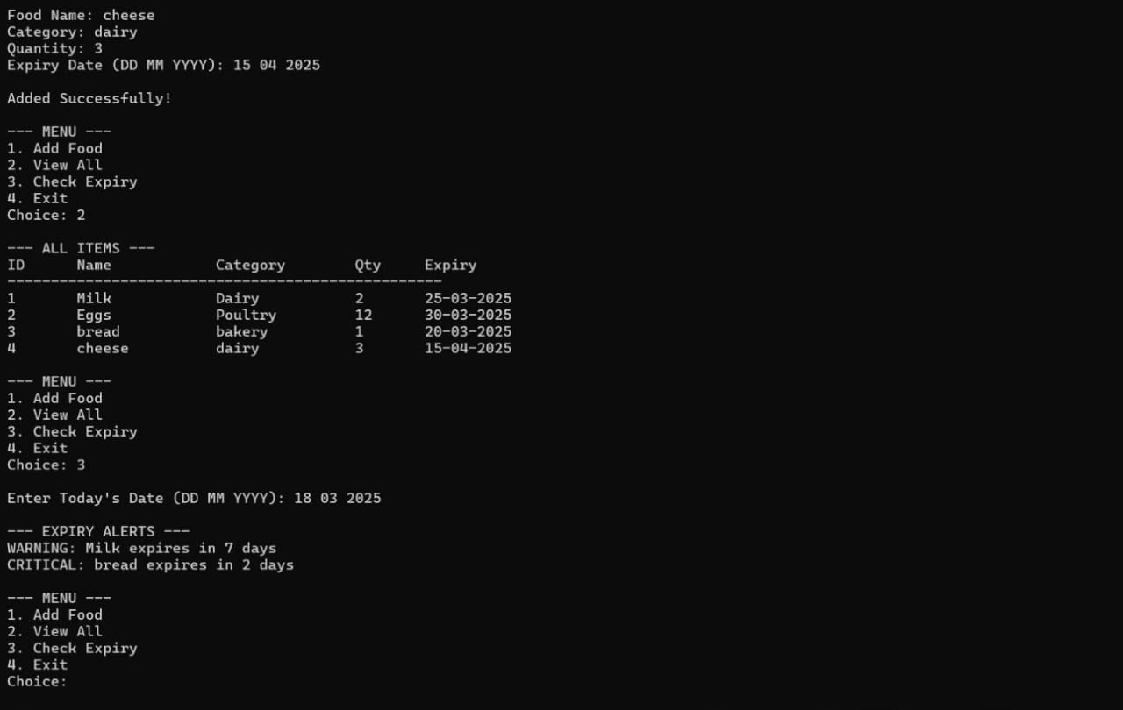

Step- 5:-
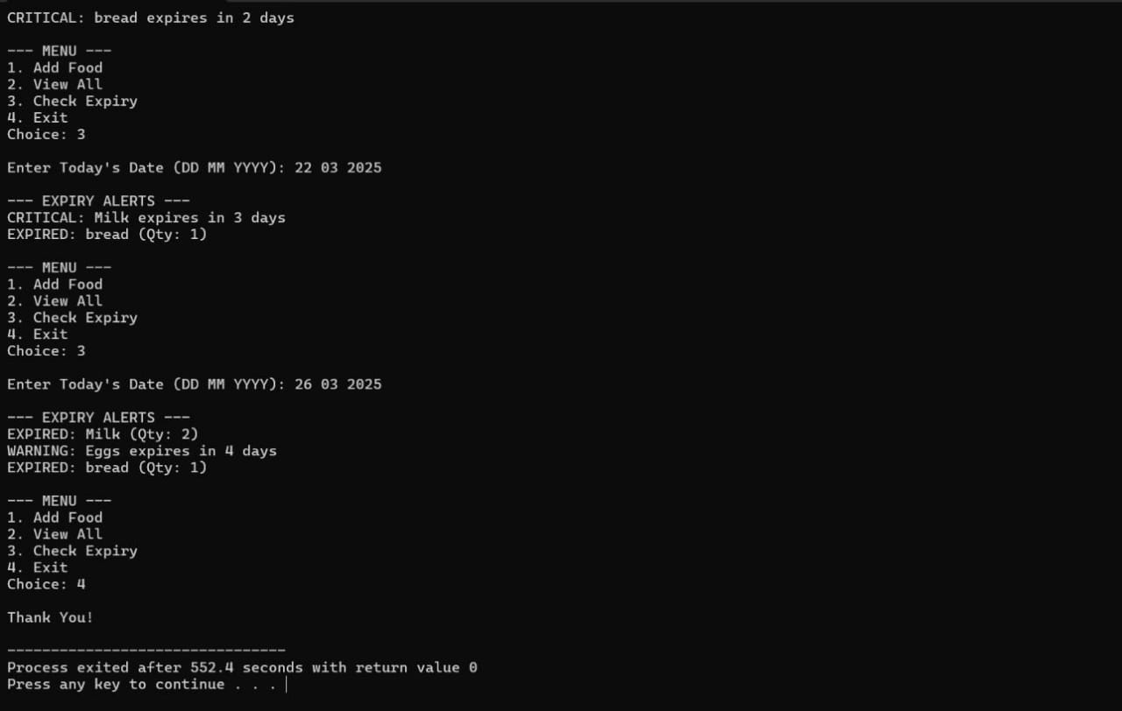

Result:- The above program is executed successfully.

